The First Help I Require would be I wish to click the Mastercard Button which will navigate to the payment page. The details of the Image Path, Floor Price and the Item Name to be retrieved and shown on Image 2 below the fields.

**Image 1**

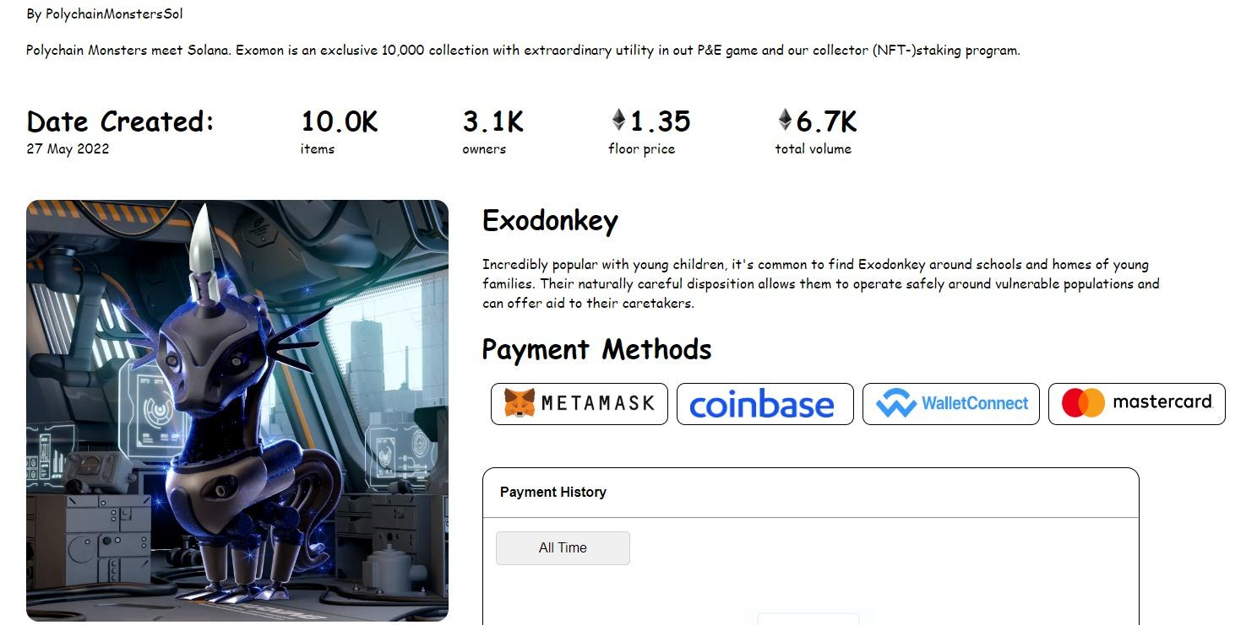

**Image 2**

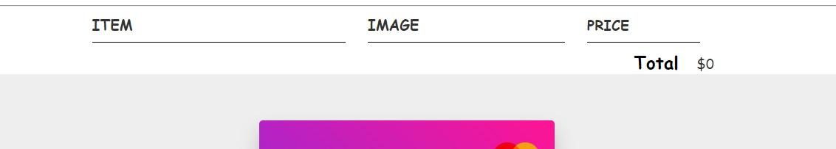

The Second Help I Require would be the creation of the Registration Page. I have done alr the HTML. The help I require now is the CSS part where I need ur help to design it to look something like as shown below.

